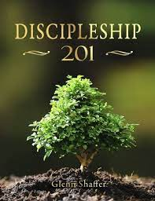
Discipleship Class 201
Discovering My Spiritual Maturity

Class 201 is designed to teach you about these simple habits (the Bible reading, Prayer, Tithing, Fellowship) and show you the different steps you can take to mature and grow as a Christian. This class will be held on Sunday, March 12, 19, 26, & April2, Four Sundays. 10:30 am.
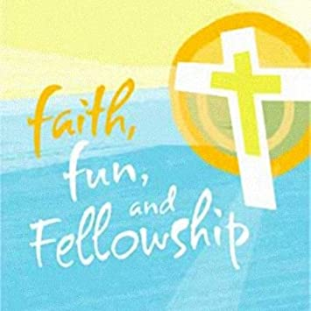
Wednesday Connections

A way to connect unchurched friends and family to our church family in an inviting atmosphere through the sharing of a meal and devotion.
Meal serving at 4:45-6 pm. Devotion at 6-6:30 pm.
Children’s School begins at 6-6:45 pm
Leadership Retreat

February 3rd, Fri. 5-8 pm, 4th, Sat. 9 am-1 pm with a book, Being The Church in a Post-Pandemic World by Kay Kotan. It’s time to renew our heart and mind to become a
healthy, vital, culturally relevant church.
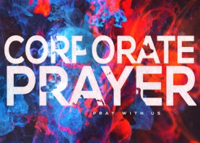
Prayer Workshop

Want to pray like Daniel or Hannah? Want to be renewed spiritually?
January 15, 22, 29, at 10 :30 am

Topic: The necessity in Revival, The focus of Kingdom-centered prayer,Three principles of Kingdom-centered Prayer.
Jesus in the Wild during Lent
10:30 am, Sunday. Feb. 26 – Mar. 2
6 – 6:30 pm, Wed. Mar. 1 – Apr. 5

What is the meaning within the remarkable scene in Luke 4:1–14 of Jesus being challenged by the devil in the “wild”—the untamed and unruly wilderness? And what are the surprising implications of this event for followers of Jesus today?
In Jesus in the Wild you’ll take a forty-day journey into the heart of one of the most unusual, and often most misunderstood, stories in the Gospel accounts. In this encounter, following his baptism in the Jordan and before the inauguration of his ministry, Jesus is alone with the adversary—the one whose works he had come to destroy (1 John 3:8). He faces three tests, or “temptations”—all aimed at unseating him from his identity, his belovedness, and his purpose as the Son of God.
UNITED WOMEN IN FAITH

Meets every first Monday of each month at 5:30 pm, except for January, July and August.
UNITED METHODIST MEN
Meets every first Saturday of each month, at 8 am.
UMC of WISCONSIN’S VOLUNTEERS IN MISSION

Marion, Alabama, February 4-12, 2023 to partner with a Marion group to do home repair. More information available on the mission outreach bulletin board. If interested, please contact Charlene Galston.
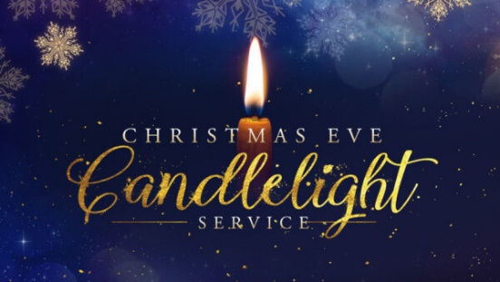

Christmas Eve Candlelight Service

December 24, 2022
Saturday
5 pm

UMC MISSION STATEMENT:
"To make disciples of Jesus Christ for
the transformation of the world.”

Black River Falls
United Methodist Church

PASTOR Rev. Inwha Shon
ORGANIST Matthew Schluntz
MUSIC DIRECTOR Amanda Lang

100 North Fourth Street, Black River Falls, WI. 54615
Phone: 715-284-4114
www.brfumc.org & Black River Falls United Methodist Church Facebook & brfumc at YouTube

ORDER OF WORSHIP
Prelude Bells
Gathering
Special Music O Holy Night Dan Brauner
Lighting of the Candles
Speaker 1: Lighting a candle in the darkness helps us find our way. In darkness we lose direction. We cannot see where we have been or where we are going. A single candle, flickering brightly, helps us find our way again.
Hymn Come, Thou Long Expected Jesus #196 Vs. 1
Speaker 2: Fire burns. It hurts. It can destroy. Fire also gives warmth and light. The coming of Christ is both a day of judgment and a day of promise. Two candles, flickering brightly, help us remember that the coming of Christ has many meanings.
Hymn Once in Royal David’s City #250 Vs. 1
Speaker 3: The light glowing from our Advent wreath is burning brighter. This radiance warms our hearts and fills us with joy! The Lord has done great things for us. Let us rejoice.
Hymn Good Christian Friends, Rejoice #224 Vs. 1
Speaker 4: Once God’s plan was a mystery, hidden from our sight. Now God has disclosed what was kept secret for so very long; he has brought it out in the light. In the brighter light may we see more clearly the glory of God in Christ and sing of the steadfast love of the Lord forever.
Hymn He Is Born #228 Vs. 1
Pastor: The season for watching and waiting is over. The people who walked in darkness have seen a great light. This is the light of the world, and the darkness cannot extinguish it. Now the time is near! The one who will save us, brings God’s light into our world. We light this Christ Candle in celebration of God’s most precious gift to us – our Savior Jesus Christ. AMEN.
Hymn Go, Tell It on the Mountain #251
Opening Prayer
Gracious God, with joy and thanksgiving we gather as your people. We have come to hear again the timeless story of Christ’s birth. In the excitement of this night, quiet our hearts that we may know the peace and fullness of this holy time. Shine, O Light, in the darkness of our world. Sing, angels, in the stillness of our hearts, “Glory to God in the highest, and on earth peace among those God favors.” This we pray in the name of the Child of Bethlehem. Amen.
Word and Response
Reader 1: Luke 2:1-5
¹ In those days Caesar Augustus issued a decree that a census should be taken of the entire Roman world. ² (This was the first census that took place while Quirinius was governor of Syria.) ³ And everyone went to their own town to register. ⁴ So Joseph also went up from the town of Nazareth in Galilee to Judea, to Bethlehem the town of David, because he belonged to the house and line of David. ⁵ He went there to register with Mary, who was pledged to be married to him and was expecting a child.
Hymn Oh Little Town of Bethlehem #230
Reader 2: Luke 2:6-7
⁶ While they were there, the time came for the baby to be born, ⁷ and she gave birth to her firstborn, a son. She wrapped him in cloths and placed him in a manger, because there was no guest room available for them.
Special Music Christmas Lullaby by John Rutter
Reader 3: Luke 2:8-14
⁸ And there were shepherds living out in the fields nearby, keeping watch over their flocks at night. ⁹ An angel of the Lord appeared to them, and the glory of the Lord shone around them, and they were terrified. ¹⁰ But the angel said to them, “Do not be afraid. I bring you good news that will cause great joy for all the people. ¹¹ Today in the town of David a Savior has been born to you; he is the Messiah, the Lord. ¹² This will be a sign to you: You will find a baby wrapped in cloths and lying in a manger.” ¹³ Suddenly a great company of the heavenly host appeared with the angel, praising God and saying, ¹⁴ “Glory to God in the highest heaven, and on earth peace to those on whom his favor rests.”
Hymn Hark the Herald Angels Sing #240
Reader 4: Luke 2:15-20
¹⁵ When the angels had left them and gone into heaven, the shepherds said to one another, “Let’s go to Bethlehem and see this thing that has happened, which the Lord has told us about.”
¹⁶ So they hurried off and found Mary and Joseph, and the baby, who was lying in the manger. ¹⁷ When they had seen him, they spread the word concerning what had been told them about this child, ¹⁸ and all who heard it were amazed at what the shepherds said to them. ¹⁹ But Mary treasured up all these things and pondered them in her heart. ²⁰ The shepherds returned, glorifying and praising God for all the things they had heard and seen, which were just as they had been told.
Hymn The First Noel #245
Devotion Rev, Inwha Shon
Special Music Anthem “Night of Silence” by Daniel Kantor
into Silent Night #239
Candle Lighting Together
Pastor: Christ the Savior is born.
Go and spread the good news everywhere!
People: Thanks be to God
Hymn Joy to the World #246
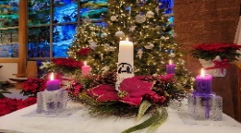
Postlude Bells

